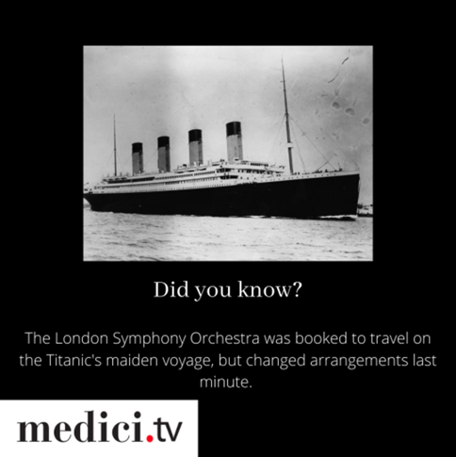
A Netflix for classical music did you hear us say? YES, yes you did! Grab your library card and check it out now.

